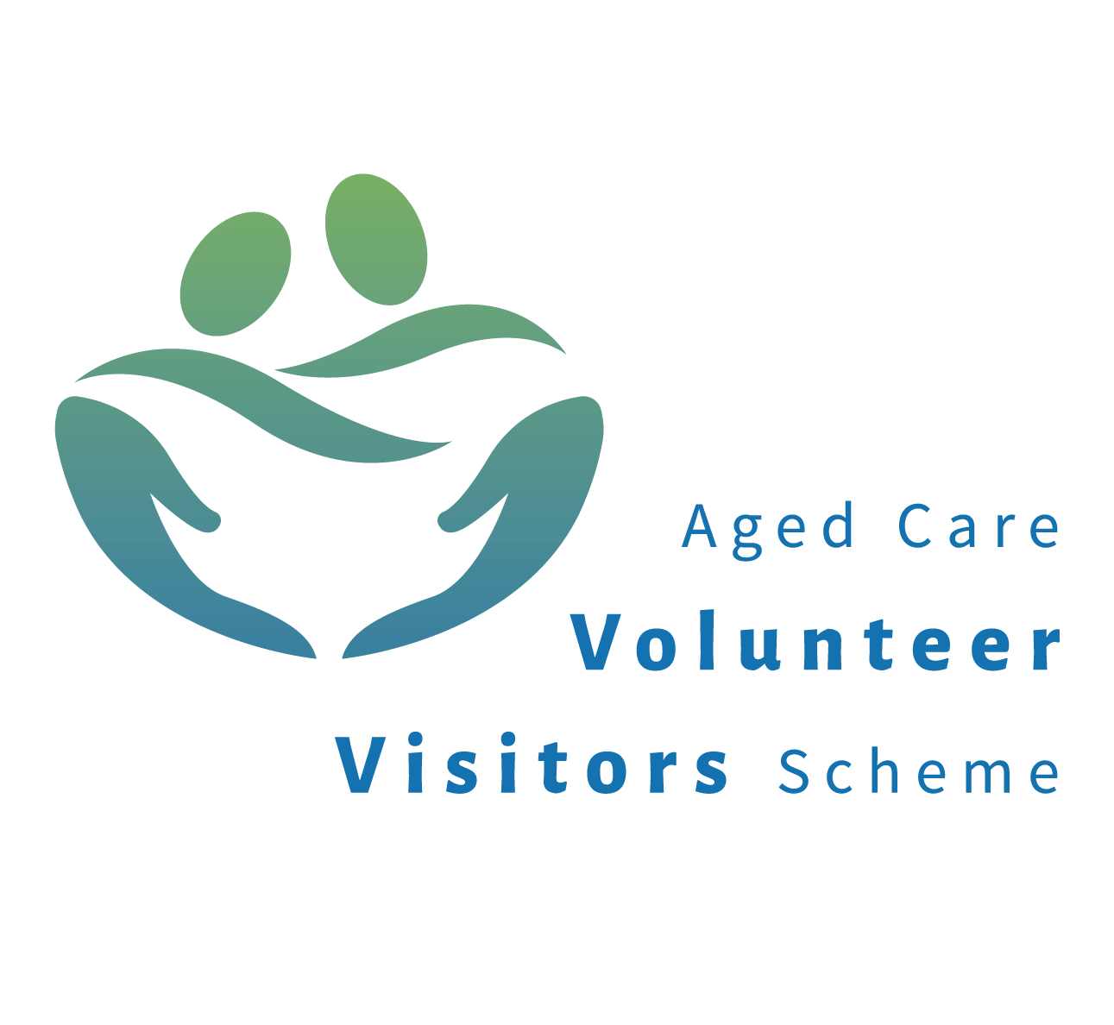

**FUnded by the Australian goverNMent**

**Volunteer Handbook**

**Welcome to Inclusion Melbourne’s Aged Care**

**Volunteer Visitor Scheme**

**A message from the Manager of Community Support**

On behalf of Inclusion Melbourne (IM), I would like to welcome you as a volunteer.

We hope that your involvement as an Aged Care Volunteer Visitor will be a rewarding and fulfilling experience for you and that you enjoy bringing companionship and friendship to the recipient(s) you will be matched with.

Our volunteers are the backbone of this program. We value your contribution and commitment and will provide you with ongoing support.

The Community Support team is passionate about volunteering and the benefits it brings to both volunteers and recipients.

Our Community Support Coordinators have a wealth of experience in disability and community services. You will find more information about their experience on the Volunteer Hub.

Thank you for your decision to become a volunteer and congratulations on joining Inclusion Melbourne.

Warmest regards

Gaye Berry

**Gaye Berry**

Manager, Community Support

Inclusion Melbourne

Contents

About the Aged Care Volunteer Vistors Scheme (ACVVS) 3

Why is the person I am visiting socially isolated? 4

Inclusion Melbourne’s philosophy of volunteering 4

The benefits of volunteering 4

Your rights as a volunteer 4

Your responsibilities as a volunteer 5

Monthly visit reports – very important! 5

Minimum Contact requirements 6

The Volunteer Hub 6

The role of the Community Support Coordinator 7

Your role as a Aged Care Volunteer Visitor 8

Police Checks 8

Visits with your match 8

What you can and can’t do as a Aged Care Volunteer Visitor 8

Tips forVisiting 9

Tips to assist you with your visits 12

Listening 13

**About the Aged Care Volunteer Visitors Scheme (ACVVS)**

The Aged Care Volunteer Visitors Scheme (ACVVS) is a national program, established in 1992 and funded by the Australian Government. The program funds organisations to recruit, train and support volunteer visitors to visit and provide companionship to socially or culturally isolated people living in Government-subsidised aged care homes or receiving a home care package in their own home.

The visits are conducted one-on-one basis in an Aged Care Home or in a person’s home, or group visits in an Aged Care Home. Our volunteer visitors also visit older people who live in their own home who receive a [Home Care Package](http://www.myagedcare.gov.au/aged-care-services/home-care-packages)**.**

Inclusion Melbourne (IM) is one of several community organisations funded to deliver this service.

Anyone can make a referral including family or friends.

## Your role as an Aged Care Volunteer Visitor

As a volunteer you demonstrate genuine empathy and understanding and are committed to developing and sustaining a friendship with your match over an extended period.

The Position Description outlines Inclusion Melbourne’s values and details the tasks and responsibilities of your role. Please take some time to familiarise yourself with your position description and the Community Support Procedures

## The role of the Community Support Coordinator

Your Community Support Coordinator role is to:

* Recruit, interview and induct new volunteers. This includes:
* Screening processes, including police checks and renewal every 3 years for ACVVS volunteers.
* Keep in regular contact with you and provide ongoing support.

Your Community Support Coordinator will stay in touch via phone calls, text messages or email. You can be assured that they are only a phone call away.

* Organise meetings, training and recognition events for volunteers.
* Keep in contact on a needs basis with the ACVVS Recipient, Aged Care Providers and other supporters of ACVVS recipients as required.

## Why is the person I am visiting socially isolated?

###### A number of reasons give rise to isolation and may include any or all the following:

###### A lack of regular and reasonably frequent contact with friends or relatives from outside of home.

* A lack of one-to-one friendships. An indigenous, culturally or linguistically diverse background that results in isolation from culture and heritage.
* Frailty or impairment that prevents involvement or participation in social or leisure activities

## Inclusion Melbourne’s philosophy of volunteering

IM values the contribution made by volunteers and seeks to recognise this by:

* Acknowledging that the relationship between volunteers and Inclusion Melbourne is a reciprocal one.
* Acknowledging that volunteers exercise free choice in committing to Inclusion Melbourne.
* Acknowledging that volunteers are of equal status and deserve the same treatment and respect as paid employees and Inclusion Melbourne can expect the same standards of its volunteers as it expects of its paid employees.
* Ensuring volunteers are not used to replace paid staff positions and only carry out work that they have agreed to undertake.
* Stating and acknowledging the contribution of volunteers in Inclusion Melbourne documentation and recording hours worked.
* Providing an opportunity for the development of skills and experience.
* Providing support in the form of clear policy guidelines, training, recognition and support. A statement of service and clarification of their role can be provided by the relevant coordinator of volunteers or program coordinator.

## The benefits of volunteering

There is much to be gained from volunteering, including the opportunity to:

* gain valuable work experience
* learn new skills
* meet new people and gain new friendships
* support others in our community who would benefit from services provided
* develop self-confidence

You can find more information about Volunteering at [www.volunteeringaustralia.org](http://www.volunteeringaustralia.org)

## Your rights as a volunteer

* Receive information and be kept informed of changes to the program.
* Receive a position description and understand the role and how it meets our objectives.
* Say “no” to additional tasks or requests beyond the position description.
* Be supported in the role by a designated staff member.
* Be reimbursed for preapproved expenses as per Inclusion Melbourne volunteer reimbursement policy.
* Provide feedback, suggestions and recommendations regarding your role or the wider program.
* Have access to dispute resolution procedures and to be supported through such a process.
* Have personal details kept in a confidential manner.
* Work in a safe and healthy environment.
* Be trained and resourced to perform duties as per role description.
* Recognition for years of services.
* Be covered by insurance.

## Your responsibilities as a volunteer

* Adhere to the role description.
* Be reliable and committed.
* Strict adherence to the confidential nature of information that may be acquired during your duties.
* Be a positive advocate of Inclusion Melbourne and the ACVVS.
* Notify Inclusion Melbourne Community Support Coordinator and other relevant staff of any absences or if you are no longer able to volunteer.
* Advise of any changes to contact details.
* Ask for support when needed.
* Abide by policies and procedures relevant to your work.
* Discuss any grievances or problems with your Inclusion Melbourne Community Support Coordinator. If issues remain unresolved, speak to Manager.
* Seek prior approval from Inclusion Melbourne Community Support Coordinator for any travel or out of pocket expenses.
* Work in a safe and healthy way and not jeopardise the health and safety of others.
* Inform Inclusion Melbourne Community Support Coordinator of any medical condition that would impact on your ability to undertake your role.
* Report any accident or injury immediately as per procedure provided.
* Smoke only in approved smoking areas
* Remain drug (non-prescribed) and alcohol free whilst undertaking a volunteer role for Inclusion Melbourne.

## The Volunteer Hub

The **Volunteer Hub** located on the **Inclusion Melbourne website.**

**The Volunteer Hub** is designed to give volunteers easy access to information and provide a simple way to report as needed.

**The Volunteer Hub** is the ‘**go to’** place for accessing:

* Community Support Team information and contact details
* Inclusion Melbourne Policies and Procedures
* Useful resources
* Link’s to Inclusion Melbourne blogs

The Volunteer Hub also has three online reporting/survey type forms to simplify documentation.

***Reporting forms are:***

1. ***Monthly activity report***

Aged Care Volunteer Visitors are asked to report monthly about their activity. The monthly activity report prompts for basic information, including what day and how many days in the month you volunteered. There is also an option to share a good news story or success about your volunteering for the month.

***The data in the report helps track progress and issues, but also provides the information we need to report to our funding bodies***

***The monthly activity report is due at the end each month***

1. ***Update personal details***

Simply access this form to notify us of a change of your contact details.

1. ***Record of an event***

The Record of Event form is completed at any time documentation is required during the course of your volunteering, such as incident, accident, injury, hazard, or a ‘near-miss’, or for any complaints or compliments or feedback.

**Note:** The Volunteer Hub does not replace routine communication between Volunteers and Support via email, telephone and text.

#### **How do I access the Volunteer Hub?**

1. Access directly via this link <https://inclusionmelbourne.org.au/volunteer-hub/>
2. Enter password provided by your Community Support Coordinator. The password will change every 6 months for security reasons.

*Note: Remember to save the password in your browser. The next time you access the site you will not have to put in the password.

1. An alternative way to access is via Inclusion Melbourne’s website. Simply google Inclusion Melbourne.
2. Click on the ‘Get Involved’ tab on the Inclusion Melbourne web site.



1. From the menu, click on the Volunteer Hub

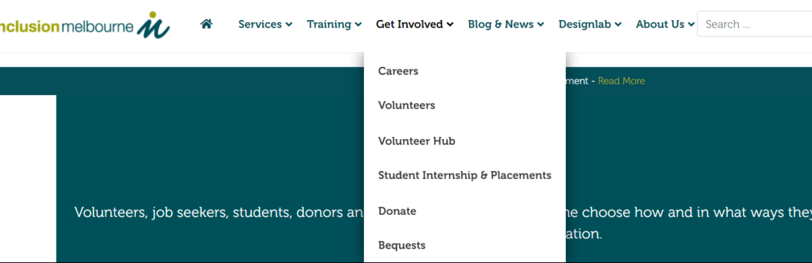

***Note: Your feedback about the Volunteer Hub is highly valued, so don’t hesitate if you can see an opportunity for improvement!***

## A further note about monthly activity reports.

Your monthly activity report ensures:

* We are kept up to date with your routine visits and activities
* We can identify trends, successes/celebrations and issues.
* Ensures we meet our funding body requirements for monthly reporting of visits

To complete a monthly report, simply access the Volunteer Hub on Inclusion Melbourne’s website.

You will be sent a reminder text each month with a direct link to the monthly activity report.

## Minimum Contact requirements

* **Weekly visits are preferred** (minimum number of visits, as per our funding is two per month). These visits need to be face to face. This is very important as your reports are a condition of our funding and are a great way to keep us posted. We enjoy hearing about your visits.

**Community Support Procedures**

Policies and Procedures are an important part of Inclusion Melbourne’s quality system and ensure volunteers and staff understand their responsibilities and act according to our mission, values, and obligations under legislation.

A suite of procedures have been written specifically for volunteers at Inclusion Melbourne, and are based on the Community Support team practice, Inclusion Melbourne Policy and Procedures, and Aged Care Volunteer Visitor Scheme National Guidelines.

See Community Support Procedures in a separate document on the Volunteer Hub,

There will be time to become familiar with these procedures, with some of them explained during your induction with your Community Support Coordinator. We ask that you take the time to read them within the first three months of your commencement. There will be an opportunity to discuss them further and seek clarification at a three-month review meeting with your Community Support Coordinator.

## Police Checks

All volunteer visitors require police checks to determine their suitability to engage with potentially vulnerable recipients. Police checks are a funding requirement of ACVVS. The Police Check is conducted at our cost.

Police Checks must be renewed every 3 years. You do not need to remember this. Your Community Support Coordinator will contact you in plenty of time prior to your Police Check expiring.

## Recipient (older person)

Under the ACVVS, the older person receiving volunteer support is referred to as a ‘Recipient’.

For your information, under the National Disability Insurance Scheme (NDIS), a person receiving services is referred to as a ‘Participant’. You may have come across other terms used by support services when referring to the people they support, such as ‘Consumer’, ‘Client’, ‘Customer’ or ‘Service User’. Inclusion Melbourne provides support to people under the NDIS, including our other volunteer roles, Leisure Buddies and Tutors. Therefore you may see the reference to ‘Participants’ and ‘Service Users’ in our staff and volunteers specific Policy and Procedures.

## Aged Care Providers

Our partnership with Aged Care Providers is critical to ensuring older people have access and benefit from this service. The role of Aged Care Providers is to ensure they support this program, are welcoming and encourage your visits. The Aged Care Quality Standards expects Aged Care Providers to show they support older people to exercise choice and independence which includes connections and relationships with others outside the aged care home.

They are also responsible for the wellbeing of older people in their care, and this may mean visits are limited or ceased during periods of illness including gastro, flu and COVID. They are requested to inform us if your older friend is unwell or in the sad case of them passing away.

If you are not permitted to visit your older friend by an age care provider, please advise your Community Support Coordinator as soon as possible.

If you are asked to complete any paperwork or training by an age care provider, *please do not complete* and advise them you will check in with your Community Support Coordinator for guidance.

## Visits with your match

You may be a little nervous on your first visit or even the idea of becoming friends with an older person. What will I say? How will they behave? Just remember, they are just like you, but older. They have had a rich life full of ups, downs, joys and sadness. Your aim is to bring them joy through your visits. If you are very worried or anxious about something, have a deadline to meet, then it may be best you delay your visit to a better time. This may be the case for your older friend too. Below are a few ideas that may assist you, however, don’t feel you need to do any of the below and you can of course, always ask your older friend what they would like to do.

* Keep them connected with family.
* Looking through photo albums, talking about loved ones, Share happy celebration stories
* Get some fresh air
* Enjoy music, books and movies together
* Trivia, puzzles, and games
* Enjoy a meal together
* Hand massage
* Read aloud

The list goes on and there are lots of ideas on the internet.

**General Guidelines for your visits**

* Weekly visits are preferred (minimum number of visits, as per our funding is two per month).
* Visits are expected to be face to face when it is possible. However, you may contact your match more often by other means, such as email, text, phone call, video call.
* If your match lives in an Aged Care Home you will need to sign in and out, when you arrive and leave. Most Aged Care Homes have a sign-in book.
* Follow specific rules of the Aged Care facility, if taking your Recipient on an outing, including if you use your car that they have the details about your car and insurance and also your driver’s license.
* Remember when out and about to have a charged mobile phone on you at all times.
* Do not take other visitors with you, including children or pets without seeking permission from your match and/or the Aged Care Service. You must also advise your Inclusion Melbourne Community Support Coordinator.

## What you can and can’t do in your role as an Aged Care Volunteer Visitor

**Do**

* Have a chat
* Have morning tea or afternoon tea
* Listen to music
* Watch TV or a DVD
* Go for a short walk
* Do some craft
* Read a book
* Go for a short outing to a cafe, park,
* Gallery or local shops

**Don’t**

* Sign or witness any papers or documents
* Assist with administering medication
* Clean houses
* Mow lawns or do gardening
* Assist with showering or toileting
* Assist with meal preparation
* Get things down from top shelves or cupboards
* Take people to appointments

**As an Aged Care Volunteer Visitor, you must not provide nursing, personal care, advocacy or comment on the level of care of the recipient NOR run a recreation activity on behalf of the Aged Care Home.**

**If you are concerned regarding the level of care of the recipient, please raise with your Community Support Coordinator NOT the Aged Care Home.**

## Tips to assist you with your visits

In this section we provide you with some useful information and suggestions to help you develop rapport with your Recipient, to ‘break the ice’ and promote enjoyable and rewarding experiences for you both.

There are many ways of communicating, and silence, or just holding a hand can make a tremendous difference to anybody’s day.

Try some of the following ideas and be guided by your friend’s cognitive and physical abilities. Remember, *it takes so little to* *give so much.*

The following information together with your sensitivity and gentle prompting will enable you to find out which topic your friend enjoys most.

#### **Conversation Starters**

* + What’s new at home; new people, pictures, furniture, plants in the garden.
  + Events and holidays including special events at the Aged Care Home
  + New buildings, shops, roads.
  + Houses for sale in the area
  + Local festivals, concerts, plays and movies.
  + If from another suburb or country town, try to get the local paper.
  + Radio and TV programs, new and old shows. Get your friend to describe them to you and to tell you about them.
  + Famous people, gossip, e.g., Royal family; Prime Minister; new Government.
  + New products on the market, e.g. mobile phones, internet and email.
  + Books read, and newspaper articles
  + What type of music do you enjoy listening to

#### **Reminiscence**

* For an older person, reminiscing can be very therapeutic and is generally very much enjoyed.
* People with dementia can really benefit from reminiscing because it utilizes long term memory rather than short term memory. Questions need to be simple and easy to understand and you have to allow more time for the response. If at all possible, find quiet and comfortable surroundings.
* Reminiscence can be wholly verbal, but it is sometimes easier for the resident to have a visual trigger. You could suggest to your friend that his/her reminiscences could be transcribed in a *This Is Your Life* type book. This could be done on a regular basis and the resident should have whole ownership of everything in the transcript.
* Your Inclusion Melbourne Community Support Coordinator will be able to give you more detailed information if you consider recording a life history. Please feel free to contact us. Here are some topics which could be of help to you:

#### **General Topics of Discussion**

**Family Life-Your Childhood**

* What does the first house you remember look like? Describe the street where you lived
* Describe your family, parents and siblings, as you saw them.
* What are some of your favourite memories of your childhood?
* What were your favourite foods?
* Tell me about the pets you had.
* What sort of chores were you expected to do?
* What does your family name mean?
* Did you have a favourite toy or play special games?

**School Days**

* Which school did you go to and what were your teachers like?
* What was discipline like at school and what subjects did you enjoy most?
* Did you sing or play any musical instruments?
* How did you get to school, and did you play any pranks?
* Did you have many friends?

**Adolescence**

* What were your favourite pastimes as a teenager?
* Was there a special person or group who influenced your life?
* What was an important change which happened to you as a teenager?

**Adulthood**

* What music did you enjoy, popular radio programs, soap operas, etc.?
* Which movie and screen stars did you like - silent and talking?
* Did you like your first job?
* What first attracted you to the person you married? What kind of things did you and your spouse do together? Tell me about your children.
* Did you have family picnics and outings?

**Style Changes**

* Men’s and Women’s outer wear and headwear including hairstyles.

**Transportation**

* Horse and cart / horseback, first cars, bus, tram rides / train experiences

**Historical Events**

* The Depression, shortage of food and money. World War 1/World War 2.

**Headlines and News Events of the Past**

* National interest and local interest - 1923: Police strike, 1930: Phar Lap won the Melbourne Cup, 1930: Dame Nellie Melba died, 1936: Edward VIII abdicated, 1948: The first Holden produced, 1956: Television in Australia.

**Prime Ministers and their Programs**

* Ben Chifley, Robert Menzies, Gough Whitlam, Bob Hawke, Paul Keating, John Howard

**Immigration**

* Identification with homeland, language problems. Expectations in a new land, interaction with others.

**Celebrations**

* Religious, Cultural and Birthdays

**Validation**

* Validation is a therapy used for communicating with residents who have Alzheimer’s disease or related dementias.
* People with dementia may appear to struggle to resolve unfinished business and display physical and behavioural traits not known to you.
* Validation is based on the notion that there is a reason behind all behaviour.
* All you have to do is be:
  + Non-judgemental and show them respect and be an empathic listener.
  + Accept their view of reality and you will soon notice that their anxiety is reduced.
* Being mindful of the above, helps maintain/restore your friend’s dignity and build a trusting relationship.

**Activities**

As you get to know your friend and their interests and skills you may consider doing some activities together.

Before planning an activity, consider the following:

* Ask your friend if he/she would like to be involved in a particular activity.
* Ask your Community Support Coordinator or staff at the residential facility about the Interests / abilities of your friend
* Choose a comfortable area, be calm, supportive and well prepared with creativity in mind.
* Recognise limits to avoid frustration
* If you are visiting at a residential facility, you will generally be welcomed to join in with your friend in activities they are involved in.
* Your friend may enjoy showing you what he/she can achieve and enjoy you being present.
* An activity performed can give a sense of purpose and enjoyment.

The following are a few ideas of activities you can share with your friend and we are sure you know of many more. Please share them with us.

**Discussion Resources**

* Photo albums, Travel brochures, Magazines and newspapers, Theatre Programs and short stories.

**Sensory Interaction**

* Hand and shoulder massage, manicure and nail polish.
* Music, especially popular songs from their era.

**Craft Suggestions**

* Hang a calendar (mark special events, your next visit, day, date, weather).
* Floral arranging with dry or freshly cut flowers or gardening in pots.
* Creative writing cards (cardboard, magazine pictures or stickers).
* Painting, printing, and folk art. Make bread dough shapes and bake at home.

**Game Ideas**

* Simple jigsaws, Cross word puzzles, Noughts and Crosses, Cards, Chess, Dominoes, Scrabble and Snakes and Ladders.

**General Topics**

* Politics, Footy tipping, Stamps and Sport, Plants and local Birdlife.

## 

## Listening

**You are listening to me when:**

* You come quietly into my private world and let me be.
* You really try to understand me even when I am not making sense.
* You grasp my point even when it is against your sincere convictions.
* You realise that the hour I took from you has left you a bit tired and drained.
* You allow me the dignity to make my own decisions even though you think they might be wrong.
* You do not take my problem from me, allow me to deal with it in my own way.
* You hold back from the desire to give me a word of good advice.
* You give me enough room to discover for myself what is really going on.
* You accept my gift of gratitude by telling me how it makes you feel being helpful.